

**School of Information Technology**

Course : Diploma in Business Informatics

Subject : ITP282 - Enterprise Application Development & Project

AY / Sem : 2018 S2

# Practical 4a: Security: Login and Roles in ASP.NET

OBJECTIVES:

By the end of this Practical students should able:

1. To implement the security using ASP.NET controls.

### Accessing the ASP.NET Web Configuration Tool in Visual Studio 2015

**1.** Open the Command Prompt (not as administrator)

2. Copy and paste the following command into Command Prompt and press enter key

"C:\Program Files\IIS Express\iisexpress.exe" /path:c:\windows\Microsoft.NET\Framework\v4.0.30319\ASP.NETWebAdminFiles /vpath:"/asp.netwebadminfiles" /port:8089 /clr:4.0 /ntlm

Upon successful execution, the message as following will be displayed, which indicate the **IIS Express is running**.

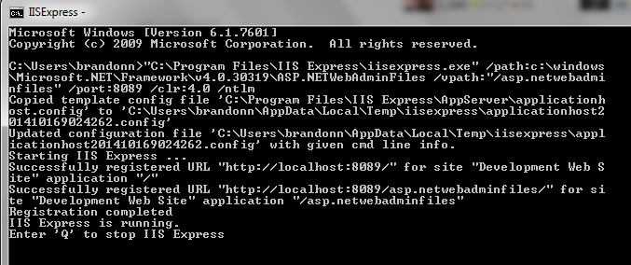

3. Change the [**Exact_Project_Path**] in the following URL to your website folder.

http://localhost:8089/asp.netwebadminfiles/default.aspx?applicationPhysicalPath=[**Exact_Project_Path**]\&applicationUrl=/

Example:

Website path in windows explorer:

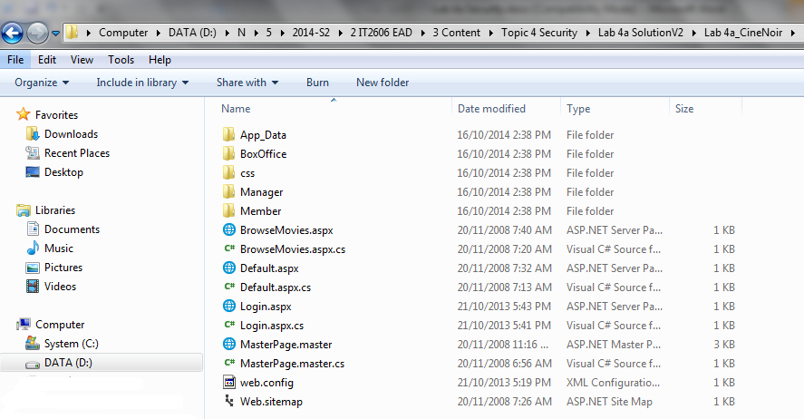

The URLs:

http://localhost:8089/asp.netwebadminfiles/default.aspx?applicationPhysicalPath=**D:\N\5\2014-S2\2 IT2606 EAD\3 Content\Topic 4 Security\Lab 4a SolutionV2\Lab 4a_CineNoir**\&applicationUrl=/

3. Launch an Internet Explorer, copy and paste the above URL to enter the **Web Site Administration Tool**.

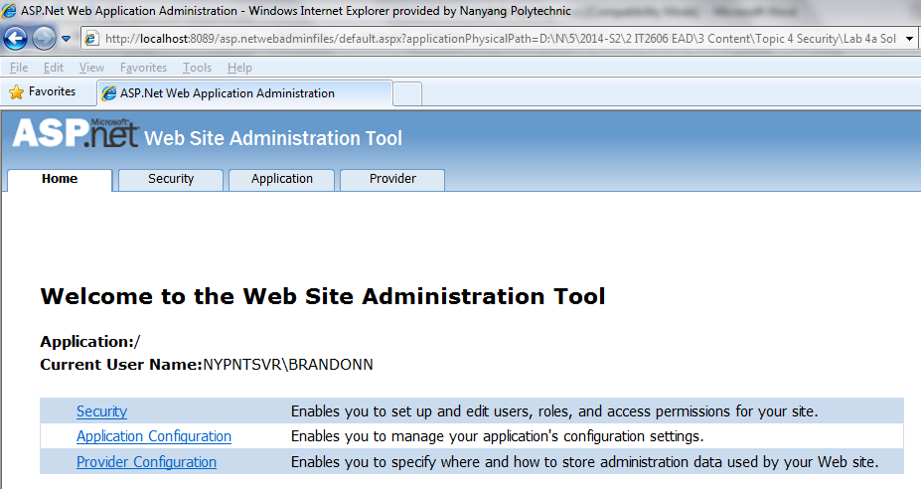

At the DOS prompt, there is indication status:-

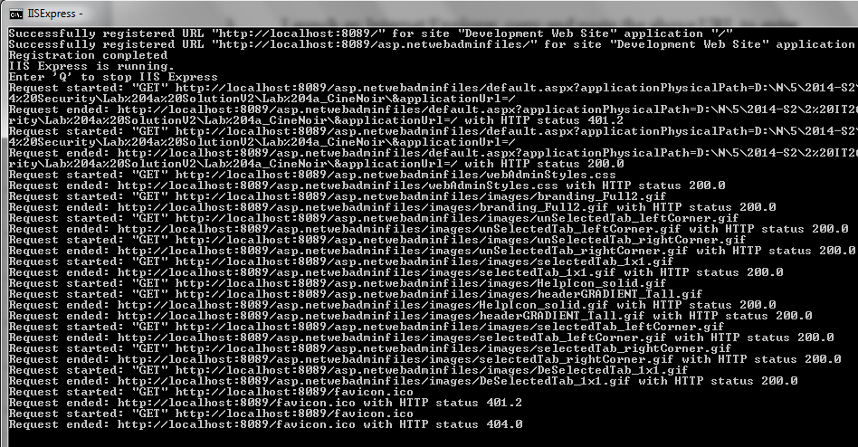

References:

* http://blogs.msdn.com/b/webdev/archive/2013/08/19/asp-net-web-configuration-tool-missing-in-visual-studio-2013.aspx
* http://stackoverflow.com/questions/20541680/visual-studio-2013-and-asp-net-web-configuration-tool

## Setting Up Security

ASP.NET has built in security, login controls and user roles. To use these, you must first set the security settings. We do this through the ASP.NET Website Administration Tool.

1. In the ASP.NET Website Administration Tool webpage, click the ***Security*** tab or link.

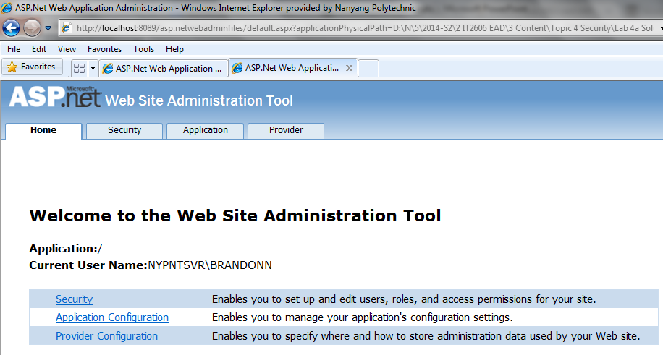

1. Click *Use the security Setup Wizard to configure security step by step* link.
2. At step 1 of the wizard, you may want to read the welcome message to get an idea what you are about to do. Click *Next*.
3. At step 2, select *From the internet* and click *Next*.
4. At step 3, click *Next*.
5. At step 4, tick *Enable Roles for this Web site* and click *Next*.
6. We will need 3 roles. Type "Manager" in to the text box and click *Add Role*.
7. Create 2 more roles:
   1. BoxOffice (no spaces)
   2. Member
8. Click *Next*.
9. Create the following users. Click *Create User* and *Continue* after each user. (For convenience, we use the same passwords, security questions and answers)

|  |  |  |  |
| --- | --- | --- | --- |
| **Field** | **User 1** | **User 2** | **User 3** |
| **User Name** | JackTan | CindyQ | SomeJoe |
| **Password** | pa$$word | pa$$word | pa$$word |
| **Email** | Your NYP email address | A classmate's NYP email address | Another classmate's NYP email address |
| **Security Question** | Green | Green | Green |
| **Security Answer** | Green | Green | Green |

1. Click *Next*.
2. In step 6, we define which roles can access which folders. This will control who can or cannot see the web pages inside each folder. First we set the rules for the BoxOffice Folder.
   1. Click the *+* icon next to the CineNoir folder. This will expand and show you the various folders in the website.
   2. Click on the *BoxOffice* folder.
   3. Select the *Role* radio button.
   4. Select *BoxOffice* in the dropdown list.
   5. Select the *Allow* radio button.
   6. Click *Add This Rule* button.

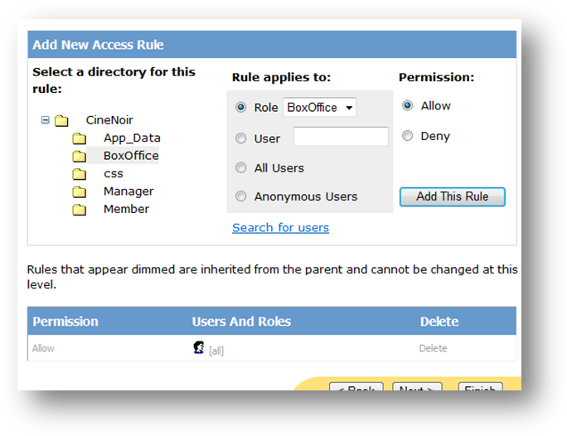

Figure 1

1. Add another rule for the *BoxOffice* folder. This time *Allow* role *Manager*.
2. Add a third rule for the *BoxOffice* folder. *Deny All Users*.
3. You should see the following at the bottom of the page. The order of the rules is important! The topmost rules take precedence over the ones below. In this case, although we Deny All Users in the third rule (from the top), Manager and BoxOffice are still allowed because the rules are above. The greyed out rule (Allow All) is a default rule and cannot be changed. However, because it is the bottommost rule, it is overridden by our third rule.

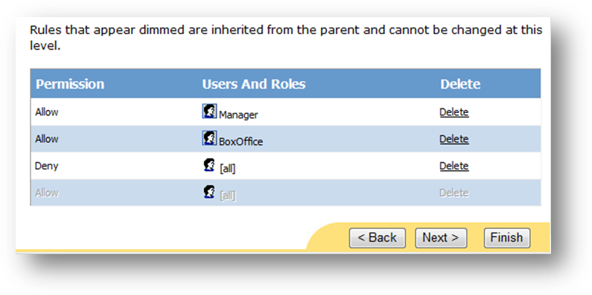

Figure 2

1. Now select the *Manager* folder and add a rule to *Allow Manager* role and a second rule to *Deny All Users*.
2. For the *Member* folder, add a rule to *Allow Member* role and a second rule to *Deny All Users*.

**NOTE:** The name of the folders and the roles are the same by pure coincidence. They do NOT have to be the same. It is helpful if they are the same for keeping the website organized.

1. Click *Next*.
2. Click *Finish*.

We have now completed setting the security settings. Now only Member role can access the Member folder and the pages inside, only Manager and BoxOffice role can access the BoxOffice folder, and only the Manager role can access the Manager folder.

What we will do next is assign users to roles.

## Assigning Users to Roles

1. At the Security page, click *Manage Users* link.
2. You should see the 3 users we created earlier. Click *Edit roles* in CindyQ's row.
3. When the roles appear, tick *BoxOffice*. This is automatically updated to the database. You need not click any buttons to save the setting.
4. Make JackTan a manager and SomeJoe a Member.
5. Close the browser.

Now, examine the Solution Explorer. Click the refresh icon and expand the *App_Data* folder. You will see that Visual Studio has added a new database file named ASPNETDB.MDF. This database also contains quite a few new tables with names starting with "asp_". These tables are used by ASP.NET to keep track of your users and roles.

You can also use the same database for other tables in the same website. It is strongly recommended that you use the same database as it will be much easier to maintain the relationship between the users and their related information.

**TIP:** To make the ASP.NET create the security tables in your existing database, read <http://www.4guysfromrolla.com/articles/040506-1.aspx>.

If you examine the Manager, BoxOffice and Member folders, you will find that they each contain a web.config file. The access rules are stored in there.

You can test the web site now, but if you try to access anything in the Members, Box Office or Manage sub menus, the website will try to find Login.aspx. You will get an error because we have not created the login page yet.

**NOTE:** By default, the website will always look for Login.aspx as the login page. The default can be changed by making the appropriate settings in web.config. You can find out more by searching the internet.

## Creating a Login Page

Now that we have set the user, roles and access rules, we need to create a login page.

1. Add a new Web Form and name it Login.aspx. Make sure you tick *Select Master Page* and select MasterPage.master.
2. Go to *Design* view.
3. Drag a *Login* control from the *Toolbox* into the empty *Content* control.

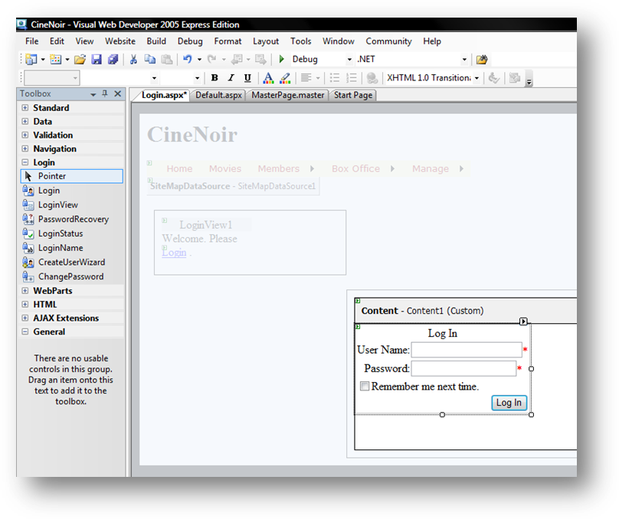

Figure 3

1. Save and test the web site again. This time when you try to access the restricted menu items, you will be shown the Login.aspx page. Login as the different users and try to access the different menu items. Do take note of our access rules earlier. For example, *Manager* role is not allowed to access the Member folder.
2. So, in a few quick easy steps, you have added security, access control and login controls to a web site.

## Displaying Login Status and Name

ASP.NET has convenient login controls that make it easy to displaying content base on login status, displaying a user's login status, name and other information. We will create a welcome message on the master page that changes depending on the user's login status.

1. Open MasterPage.Master.
2. Go to Design view.
3. There is a side panel with the words "Login control here." Delete the text, and then drag a *LoginView* from the *Toolbox* to replace it.

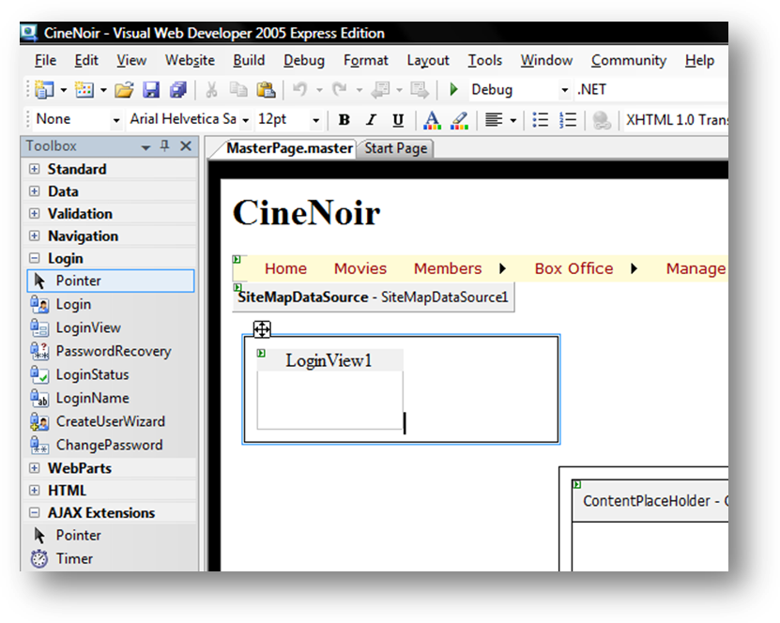

Figure 4

1. Inside *LoginView1*, type "Welcome, please ".
2. Keep your keyboard cursor at the end of the sentence you just typed and double-click *LoginStatus* in the Toolbox. (Despite, what the screenshot below looks like, do NOT type "Login" at the end of the sentence. That is the *LoginStatus* control.

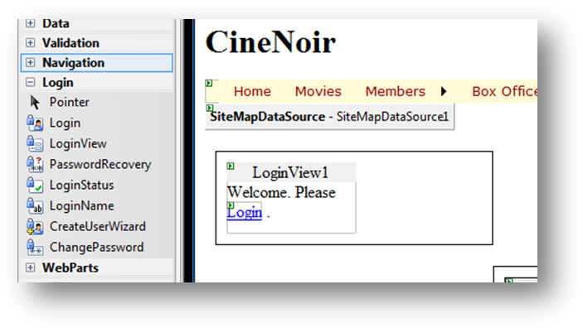

Figure 5

1. Now expand the Tasks Window for LoginView1 and select *LoggedIn Template*. Whatever you just did in the last few steps will disappear. That is normal, because you were working in the *Anonymous Template*, which is shown to users who are not logged in. It is still there, just hidden. Now we will create what is shown when a user is logged in.

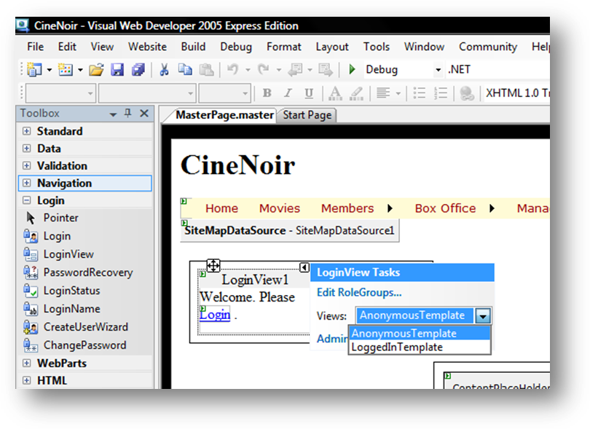

Figure 6

1. Inside *LoginView1*, type "Welcome back ." (There is a space between "back" and the full stop.)
2. Place the keyboard cursor just before the full stop and double-click *LoginName* in the *Toolbox*.
3. Now place a *LoginStatus* control after the full stop.

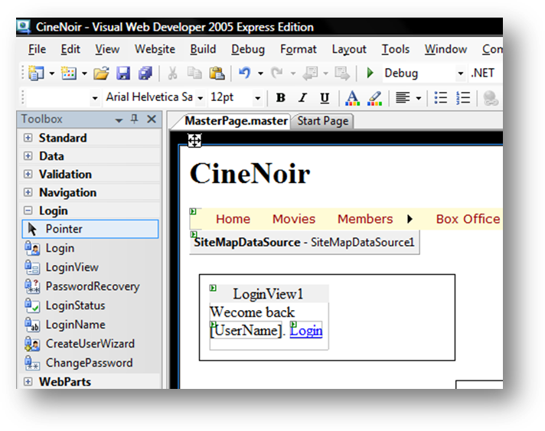

Figure 7

1. Test the web site and see how these controls work. Note that welcome message on the left changes depending on your login.

## Properties and Other Controls

For the above controls, especially the *Login* control, there are options that you can enable and disable. You can even change what texts are displayed. Explore the *Properties* panel for the *Login* control to find out how you can customize the *Login* control.

Other than these controls, there are a few more that implement standard login features, like: recovering passwords, changing passwords and creating new users. Check out the security tutorials and videos at the resources below to find out more about them.

## Resources

* <http://msdn.microsoft.com/en-us/library/tz6e5ezc.aspx>
* <http://www.asp.net/learn>
* <http://www.4guysfromrolla.com/articles/120705-1.aspx>

**========== End ==========**